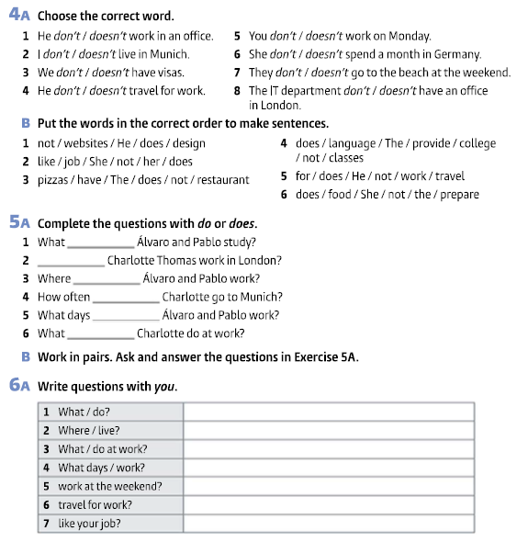

WRITING
8 - Look at the table about Soft Labs. Write a description of the company.
Company Name | Soft Labs
Business | a web and mobile app development company
Head office | Los Angeles, USA
Branch offices | 0 (zero)
Staff | 50 employees
Activities | provide product strategy, UX/UI design and IoT development services
Some Clients | World Health Organization, World Wildlife Fund, USC, UCLA
Present Project | design and develop a mobile app for a sports stock market
Website | https://softlabs.com/

Exercise 4A
1 – doesn´t
2 – don´t
3 – don´t
4 – doesn´t
5 – don´t
6 – doesn´t
7 – don´t
8 – doesn´t

Exercise 4B
1 – He does not design websites.
2 – She does not like her job.
3 – The restaurant does not have pizzas.
4 – The college does not provide language lessons.
5 – He doesn not travel for work.
6 – She does not prepare the food.

Exercise 5A
1 – do
2 – Does
3 – do
4 – does
5 – do
6 – does

Exercise 6A

- What do you do?
- Where do you live?
- What do you do at work?
- What days do you work?
- Do you work at the weekend?
- Do you travel for work?
- Do you like your job?

Exercise 8
Start like this:
Soft Labs is a web and mobile app development company. The head office is based in Los Angeles. It doesn´t have branch offices. The company has 50 employees. It provides product strategy, UX/UI design and IoT development services. The clients are World Health Organization, World Wildlife Fund, USC and UCLA. The current / present project is to design and develop a mobile app for a sports stock market. / The company designs and develops a mobile app for a sports stock market. The website is softlabs.com.

